**Theory (File)**

Data stored in array, variables and objects are temporary ; they are lost when the program terminates. To permanently store the data created in a program, it is needed to save them in a file. In order to perform I/O, one needs to create objects using appropriate java I/O classes. The objects contain the methods to read or write data from a file.

**Code**

package file;

import java.io.FileNotFoundException;

import java.util.Scanner;

public class File {

public static void main(String[] args) throws FileNotFoundException {

java.io.File file = new java.io.File("Test.txt");

if(file.exists()){

System.out.println("File already exists");

}

try (java.io.PrintWriter out = new java.io.PrintWriter(file)){

out.print("Mr.X ");

out.println(100);

out.print("Mrs.Y ");

out.println("90");

}

Scanner read = new Scanner(file);

while(read.hasNext())

{

String S = read.next();

int i=read.nextInt();

System.out.println(S+" "+i);

}

read.close();

}

}

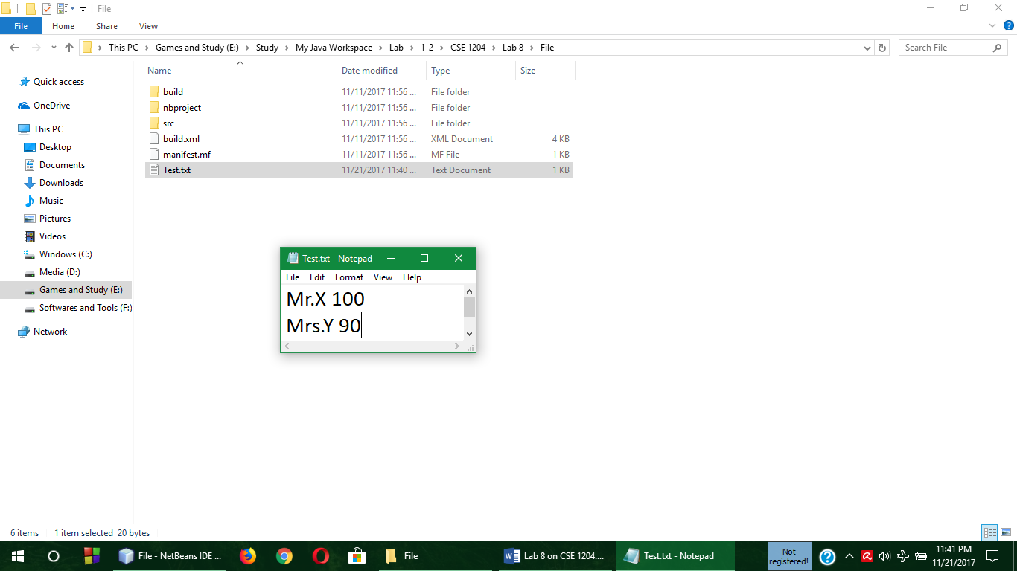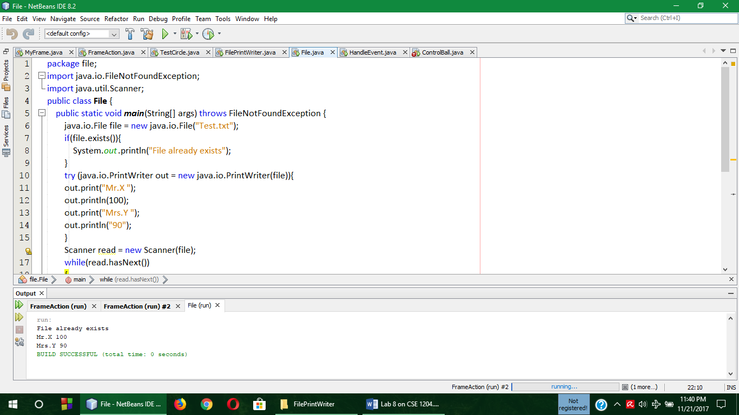**Output**

**Comment**

In the above program, the main() was present in a class named File and in that a file object was declared under the imported package java.io.File . Then two string was printed on the output console which was read in the Test.txt file. And for exception handling try() was also used.

**Theory (Handle Event)**

Action Listener is one of the methods of Java programming language. In GUI, frame, panel is used. And there are several buttons are used in the frame. But using the Action Listener method there can be many post button clicked operation or action can be performed.

**Code**

package handleevent;

import javax.swing.*;

import java.awt.event.*;

public class HandleEvent extends JFrame{

public HandleEvent() {

JButton ok = new JButton("OK");

JButton cancel = new JButton("CANCEL");

JPanel panel = new JPanel();

panel.add(ok);

panel.add(cancel);

add(panel);

ListenerClass listener = new ListenerClass();

ok.addActionListener(listener);

cancel.addActionListener(listener);

}

public static void main(String[] args) {

JFrame frame = new HandleEvent();

frame.setTitle("Demo");

frame.setSize(300,100);

frame.setLocation(200,100);

frame.setDefaultCloseOperation(JFrame.EXIT_ON_CLOSE);

frame.setVisible(true);

}

}

class ListenerClass implements ActionListener {

public void actionPerformed(ActionEvent e) {

System.out.println("The "+e.getActionCommand()+" button is clicked at"+new java.util.Date(e.getWhen()));

}

}

**Output**

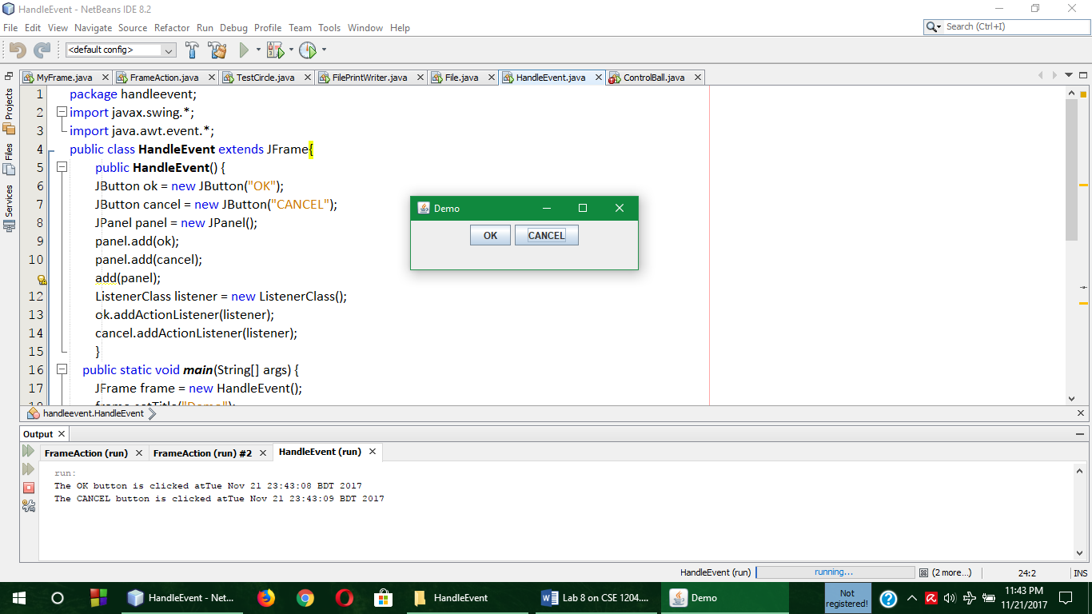



**Comment**

In the above program, for Action listener Java.awt.event.* package was imported and a HandleEvent class was declared that extends JFrame. And after that All the required properties of the frame was taken in a panel and the panel was added. Then two objects for **OK** and **Cancel** was declared from ListenerClass class and then ListenerClass class implemented from ActionListener, in that the actionPerformed function was used to print the message that will pop out on the console after the press in **Ok** and **Cancel** button.

**Theory (Control Ball)**

Control Ball is an example of action listener where the radius of a ball will shrink and Enlarge by 1 unit after pressing the Shrink and Enlarge Button respectively. Action Listener is one of the methods of Java programming language. In GUI, frame, panel is used. And there are several buttons are used in the frame. But using the Action Listener method there can be many post button clicked operation or action can be performed.

**Code**

package controlball;

import javax.swing.*;

import java.awt.*;

import java.awt.event.*;

public class ControlBall extends JFrame{

private JButton jbtenlarge = new JButton("Enlarge");

private JButton jbtshrink = new JButton("Shrink");

private BallCanvas canvas = new BallCanvas();

public ControlBall(){

JPanel panel = new JPanel();

panel.add(jbtenlarge);

panel.add(jbtshrink);

this.add(canvas, BorderLayout.CENTER);

this.add(panel,BorderLayout.SOUTH);

jbtenlarge.addActionListener(new ActionListener(){

public void actionPerformed(ActionEvent e){

canvas.enlarge();

}

});

jbtshrink.addActionListener(new ActionListener(){

public void actionPerformed(ActionEvent e){

canvas.shrink();

}

});

}

public static void main(String[] args) {

ControlBall frame = new ControlBall();

frame.setTitle("Control Ball");

frame.setSize(300,300);

frame.setLocation(400,200);

frame.setDefaultCloseOperation(JFrame.EXIT_ON_CLOSE);

frame.setVisible(true);

}

public static class BallCanvas extends JPanel{

private int radious = 5;

public void enlarge(){

radious+=1;

repaint();

}

public void shrink(){

radious-=1;

repaint();

}

protected void paintComponent(Graphics g){

super.paintComponents(g);

g.drawOval(getWidth()/2-radious, getHeight()/2-radious, 2*radious, 2*radious);

}

}

}

**Output**

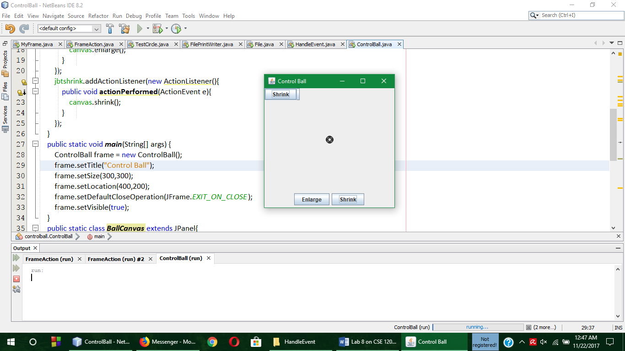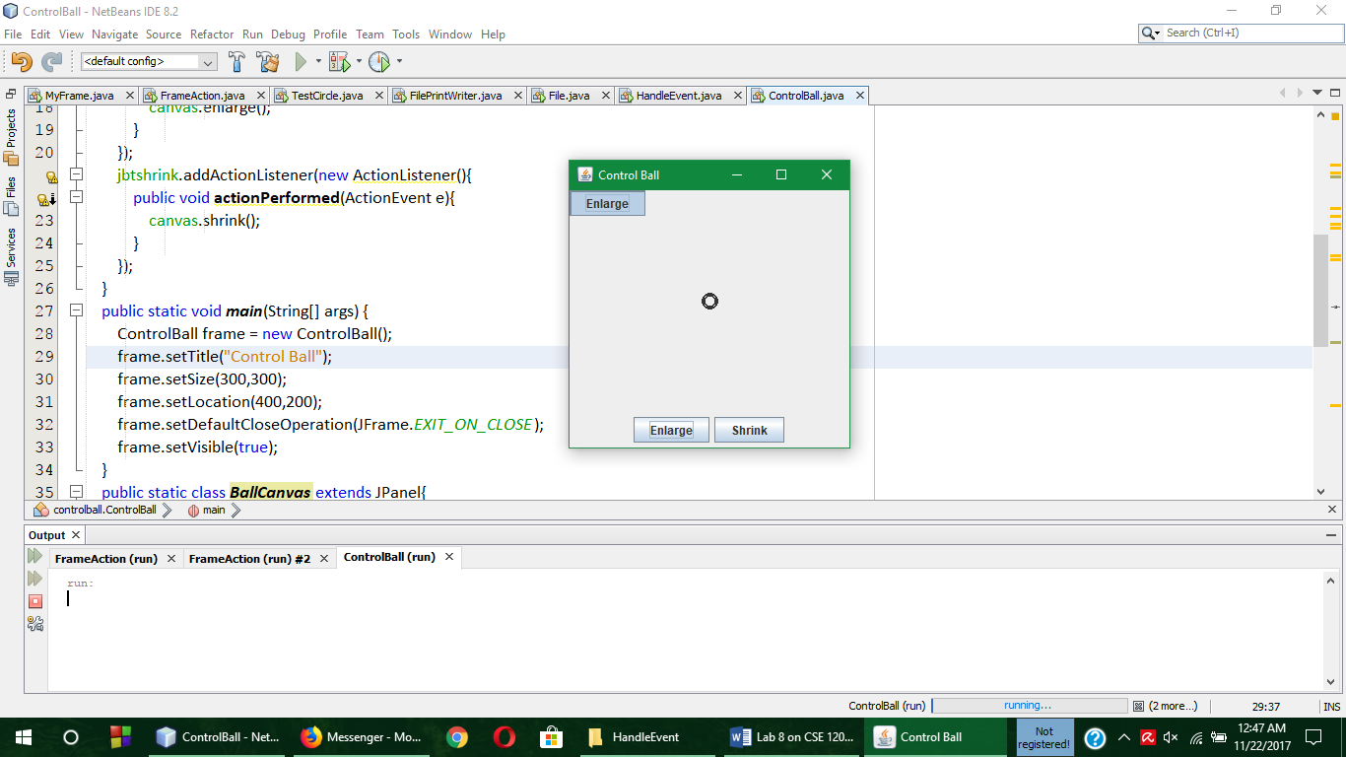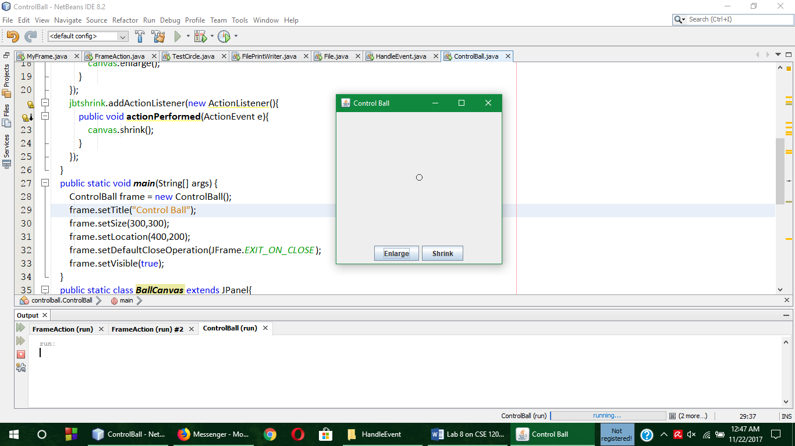

Before Enlarge and Shrink After Enlarge After Shrink

**Comment**

In the above program, for Action listener Java.awt.event.* package was imported and a ControlBall class was declared that extends JFrame. And after that All the required properties of the frame was taken in a panel and the panel was added. Then for the radius increment and decrement the actionListener method was used.